FACULTY EVALUATION
Programme Name: SBVP ALUMNI MASTERCLASS - GROW Online Tanzania (23rd March 2026 - 27th March 2026)
Session: Review current funding of social enterprise || Identify Funding Gaps || Preparing funding plan
Faculty Name: Tim Kipchumba
No. of Respondents: 8
No. of Participants: 10
Evaluation Parameter | (%) Individual Score | (%) Programme Average
Punctuality (Commencement and Completion of Sessions) | 98 | 96
How well do you understand the core concepts presented? | 95 | 95
Rate your confidence in applying the new skills learnt | 95 | 95
Degree of Faculty preparedness for the sessions | 95 | 96
Content and methodology of the program | 98 | 97
Quality of class and group discussions | 95 | 95
The information presented in the course is relevant to my work (ministry) | 98 | 94
Average scores | 96 | 95

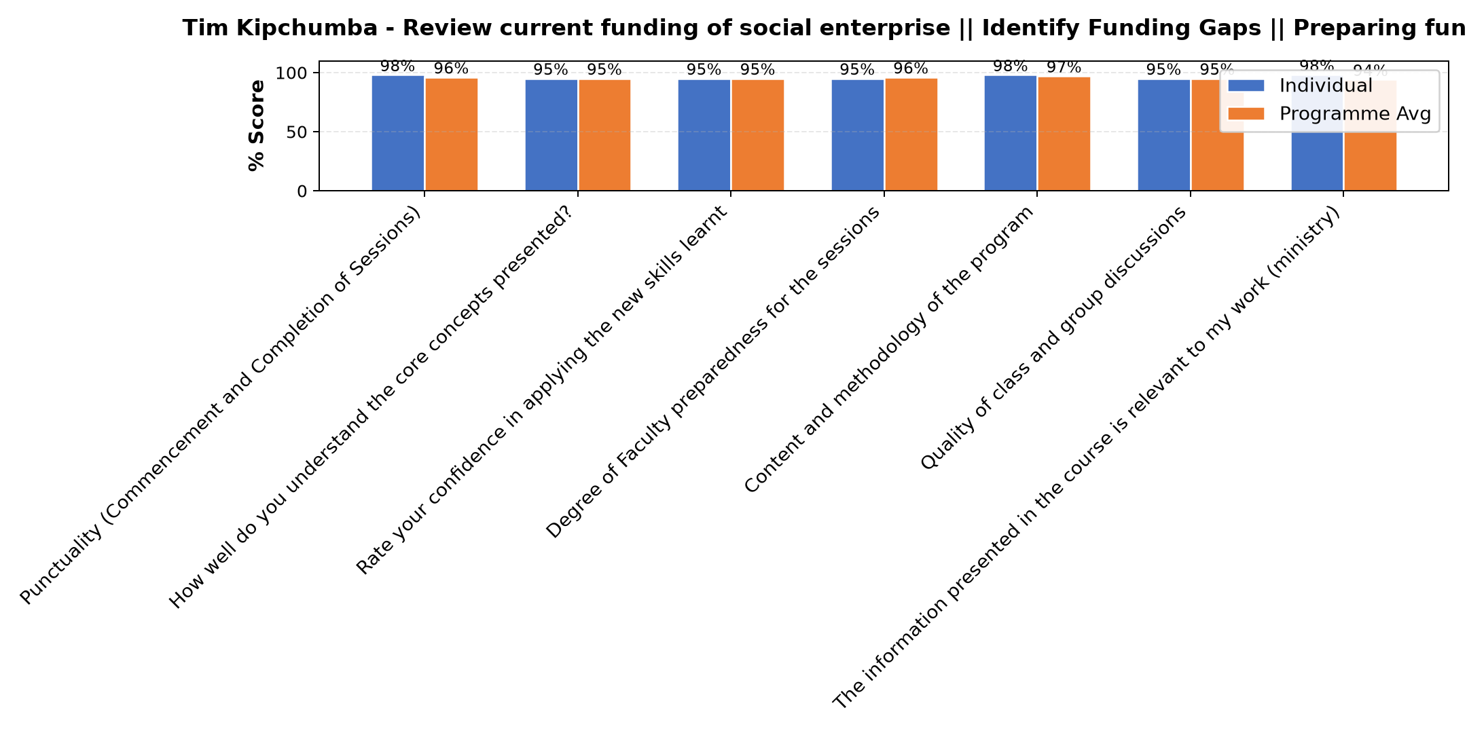

Comments & Feedback
- • The presentation was great
- • Well presented
- • Well presented
- • Not setting time for starting and finishing what l plan to do
- • Lack of finance expertise
SUBMITTED THROUGH:
SBS Evaluation Automation System

